CYBER SECURITY INTERNSHIP & TRAINING PROGRAM

Name: M REHMAN IJAZ

NETWORK PACKET SNIFFER



Contents
1. Introduction 3
2. Objectives 3
3. Technologies Used 3
4. Background Concepts 4
4.1 What is Packet Sniffing? 4
4.2 IP Protocol 4
4.3 TCP vs UDP 4
4.4 ICMP 5
5. How the Program Works 6
6. Code Explanation (High-Level) 6
7. Ethical Considerations 7
8. Challenges Faced 7
9. Results 8
10. Conclusion 10

1. Introduction
A network sniffer is a tool used to capture and analyze network traffic flowing through a system. It helps in understanding how data packets are transmitted across a network and how different protocols operate.
This project implements a basic network sniffer in Python using the Scapy library. The objective is to observe packet headers, identify protocols, and understand how network communication is structured.
This tool is developed strictly for educational purposes in a controlled environment.

2. Objectives
- Understand how network packets are structured
- Capture live network traffic
- Analyze IP, TCP, UDP, and ICMP protocols
- Extract source and destination information
- Learn about packet-level inspection

3. Technologies Used
- Programming Language: Python 3
- Library: Scapy
- Operating System: Kali Linux
- Privileges Required: Root / Administrator

4. Background Concepts

4.1 What is Packet Sniffing?
Packet sniffing is the process of capturing and analyzing data packets transmitted over a network. It is commonly used in:
- Network troubleshooting
- Security monitoring
- Traffic analysis
- Intrusion detection

4.2 IP Protocol
The Internet Protocol (IP) is responsible for addressing and routing packets between devices.
Each IP packet contains:
- Source IP address
- Destination IP address
- Protocol type

4.3 TCP vs UDP
TCP (Transmission Control Protocol):
- Connection-oriented
- Reliable data transfer
- Used for web browsing (HTTP/HTTPS), email, file transfer
UDP (User Datagram Protocol):
- Connectionless
- Faster but less reliable
- Used in streaming and gaming

4.4 ICMP
ICMP (Internet Control Message Protocol) is used for network diagnostics.
Example:
- ping command uses ICMP

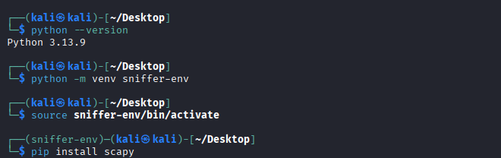

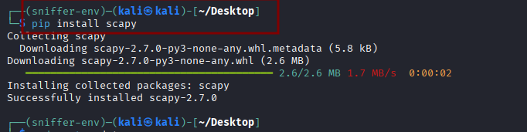

5. How the Program Works
The program performs the following steps:
- Listens to the network interface
- Captures packets in real-time
- Checks if the packet contains an IP layer
- Identifies the protocol (TCP, UDP, ICMP)
- Extracts:
  - Source IP
  - Destination IP
  - Source Port (if applicable)
  - Destination Port (if applicable)
- Displays the information on the terminal
The program does not capture encrypted payload data. It only analyzes packet headers.

6. Code Explanation (High-Level)
- sniff() → Captures live packets
- IP in packet → Checks if packet contains IP layer
- haslayer(TCP) → Identifies TCP protocol
- haslayer(UDP) → Identifies UDP protocol
- haslayer(ICMP) → Identifies ICMP protocol
Root privileges are required because packet sniffing operates at the network interface level.
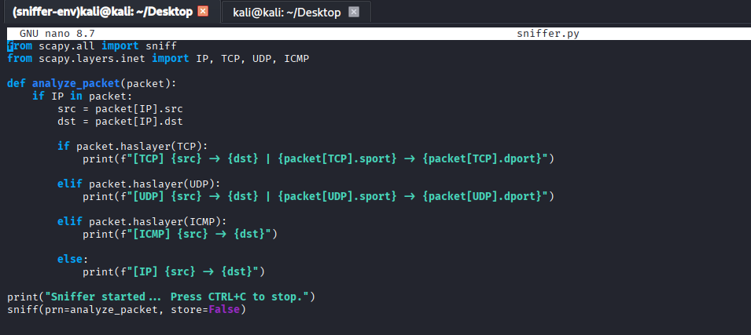

7. Ethical Considerations
Packet sniffing can be misused if performed on unauthorized networks.
This project:
Was executed in a controlled lab environment
Captured only personal machine traffic
Did not intercept third-party communication
Unauthorized packet sniffing may violate privacy laws and cybersecurity regulations.

8. Challenges Faced
- DNS configuration issues during dependency installation
- Root permission requirements
- Understanding protocol hierarchy
These were resolved by configuring DNS and running the program with administrative privileges.
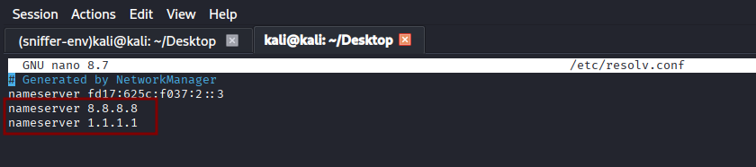

9. Results
The program successfully:
- Captured live network traffic
- Identified TCP, UDP, and ICMP packets
- Displayed source and destination information
- Demonstrated real-time packet monitoring
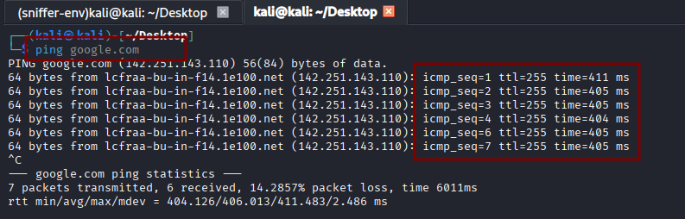
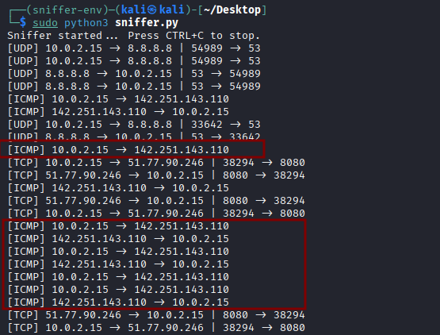

- Open any Browser and capture these TCP/UDP traffic
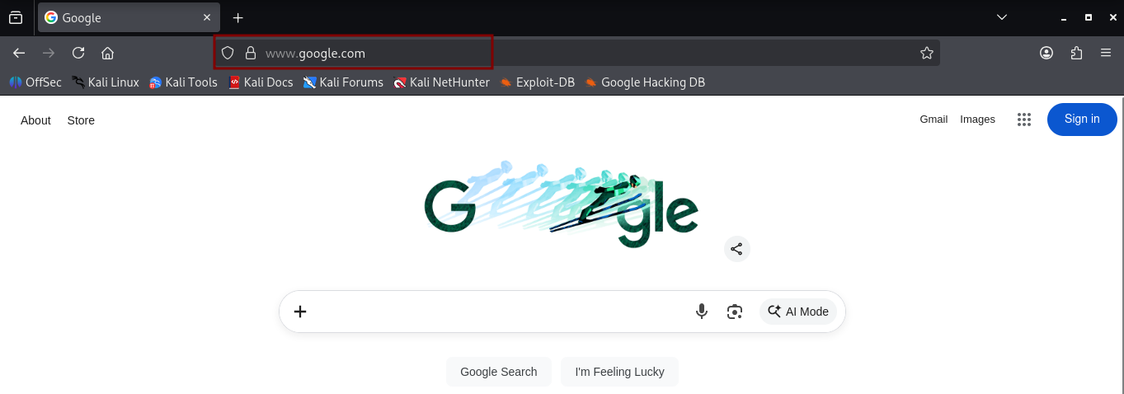

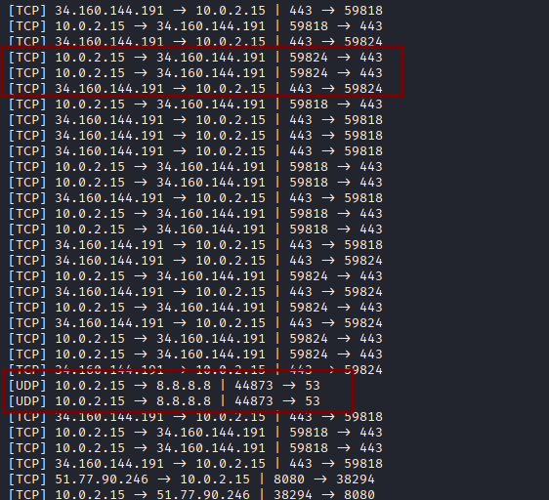

10. Conclusion
This project provided practical understanding of:
- Network packet structure
- Protocol identification
- Real-time traffic monitoring
It strengthened knowledge of networking fundamentals and cybersecurity concepts.
Future improvements could include:
- Packet statistics
- Interface selection
- Logging to file
- Filtering specific protocols

